Southern Tier Chapter of
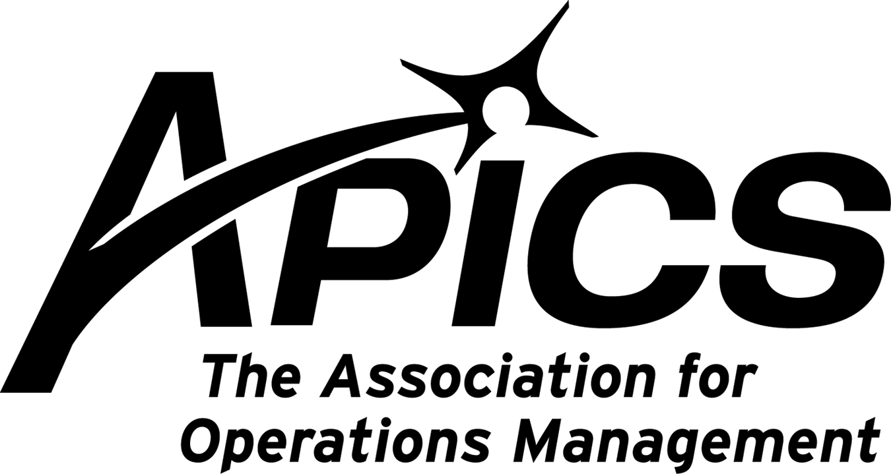
www.stapics.org

“Advancing productivity and innovation and competitive success.”

DINNER MEETING

Wednesday, February 22, 2012

Location: Grande’s Restaurant
1250 Upper Front Street, Binghamton

Guest Speaker:
Michael LoSapio, CPIM

CUT THE HYPE!
A Fresh Approach to Enterprise Resource Planning (ERP) Selection

Are you frustrated with your current ERP system? You are joined by the vast majority of companies in this frustration. Survey after survey indicates that 70% to 90% of companies are dissatisfied with their current ERP systems.

There are plenty of theories why implementations have problems, but the key reason is fundamental. The legacy selection process that is commonly used is flawed.

The Typical Approach
1. Creating a “System Requirements List” for software vendors to fill out.
2. The arduous task of reviewing “sales demos” in an attempt to decipher the differences.
3. Checking references to confirm that companies are happy with their systems.
4. And voila … you have selected the very best system for your company. Or have you?

It all seems very logical, but it obviously does not work if more than 70% of companies using this process end up being unsatisfied with their selection.

Join us as Michael LoSapio provides a Fresh Approach To Selecting ERP Systems.

Get information about the real performance you can expect from an ERP Solution.
• Learn techniques used by software vendors to make their product shine during a demo.
• Learn how to request references so the vendor can’t give you’re their best three customers.
• Learn the web sites and searches that can be used to find information from users.

By following this simple process with emphasis on the unique requirements of your organization, you will not only get the right system fit for your company, you will increase your chances of successful implementation.

Reference attached article for a preview of Michael’s Fresh Approach.

About the Presenter:
Michael LoSapio, CPIM is a Senior Account Manager with Synergy Resources LLC, an affiliate of Infor Global; Solutions where he is responsible for ERP solution sales for Infor ERP Visual. Prior to joining Synergy Resources he was an implementation consultant for Exact software solutions. A 30 year member of APICS, Mike has served as a chapter president and various chapter board positions. Mike has been an instructor for certification courses and taught Operations Management courses at the collegiate level. Mike has s B.S. and MBA from Gannon University in Erie, PA.

5:30PM Sign-in and Networking
6:00PM Dinner
6:30PM Guest Speaker

Dinner: Order off Menu

Cost: Members $20. Non-members $25.
Excludes drinks

RSVP by 2/15/12 to Kelly.noreika@lmco.com or call 607-751-7311

Thanks and hope to see you there!

PLAN NOW TO ATTEND MARCH’S PDM
Presented by Michael Ford

Ice Cream Sundae Production: From Job Shop to Lean Flow

Are you interested in comparing a job shop layout to a lean flow line? Or maybe you just missed dessert? Either way, this session will be an instructive and tasty experience!
This interactive workshop will engage you and your fellow participants by role-playing as customer order entry professionals, production planners, workstation operators, inspectors or hungry customers placing orders. The session involves two major exercises: first, a simulation of a traditional job shop layout; and then, creation of a flow line to demonstrate the improved lean environment.
Attendees will gain knowledge of the following concepts:
- The advantages of empowerment and engagement
- Lean improvements in productivity, space requirements, lead time and quality
- Some secrets you never knew about Lean (which contradict the so-called “experts”)!
This experiential learning session provides valuable lessons learned that the audience will remember years or decades later. Participants engaged in a simulation will retain more information than the standard lecture format.
Scheduled in partnership with ISM. Details coming soon.

STAPICS Educational Offerings

The cornerstone of APICS is Education. The Southern Tier chapter is proud to be able to help companies and organizations give their employees the tools to excel in the work place and benefit the bottom line. Besides our public offerings, we can also bring the APICS Body of Knowledge to your work place.

Our instructors are available to come on your site and offer training and instructions in the hottest topics in resource management. Not only can we teach CPIM (certified Production and Inventory Management) and CSCP (Certified Supply Chain Professional) courses and prepare your workforce for certification testing, but we offer courses and workshops in everything from business basics to very specialized topics.

For more information, visit our website www.stapics.org.

CAREER OPPORTUNITY:
BUYER (Commodity Manager – Fabrication/Machine/Assembly)
Greene, NY – 1st Shift
Reference attached file for details.

We’re on !!!
Come and visit, poke around, or comment on us! Our name there is “Southern Tier APICS”. It’s just another way
for us to keep in touch with our membership.



Board of Directors 2011-2012

President Director of Publicity
Dave Gardner Kelly Norieka
dgardner@akraturn.com Kelly.norieka@lmco.com

Executive VP /Director of Finance Director of Education
Steve Whited Don Sheldon
sjw6@meadwestvaco.com dsheldon@sheldoninc.com

Secretary Director at Large
Debbie Unkel Steve Stanchak
deb.unkel@raymondcorp.com steve.stanchak@infoprint.com

Director of Membership/Director of Chapter Standards/

Director of Online Publication Director of Student Relations
Lee Schechter Brian Arrnold
lschechter@stny.rr.com barnold@amphenol-aao.com

Director of Programming and Marketing Director of Communications
Michael LoSapio April McWeeney
Michael.LoSapio@SynergyResources.net april.mcweeney@mwv.com

Southern Tier APICS
PO Box 1107
Binghamton NY 13902-1107

